

**E-Commerce Website**

**Software Design Document**

– Hanoi, September 2021 –

**Table of Contents**

I. Overview 3

1. Code Packages 3

2. Database Schema 3

II. Code Designs 4

1. Login 4

a. Class Diagram 4

b. Class Specifications 4

c. Sequence Diagram(s) 4

d. Database queries 5

2. Logout 5

a. Class Diagram 5

b. Class Specifications 5

c. Sequence Diagram(s) 5

d. Database queries 5

III. Database Tables 6

1. <Table name 1> 6

2. <Table name 2…> 6

# Overview

## 1. Code Packages

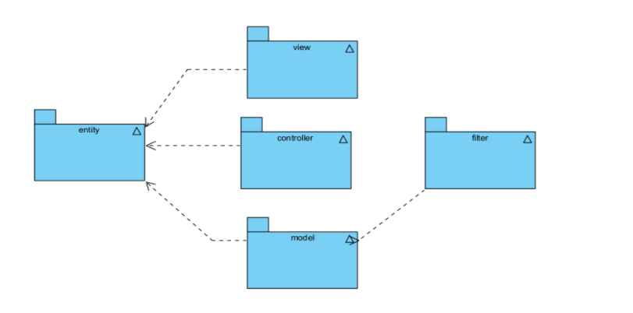

***Package descriptions & package class naming conventions***

|  |  |  |
| --- | --- | --- |
| **No** | **Package** | **Description** |
| 01 | entity | Folder has all entities that need for developing. |
| 02 | model | Name like table name in the database |
| 03 | view | Folder has all Dao classes . |
| 04 | controller | DAO + entity class name |
| 05 | filter | Folder has all files jsp ,html, css, js, images |

## 2. Coding Conventions

Put a controller or view in the certain place and give it a special name, and it magically works. If you know the conventions, you can quickly get an application up and running

# Code Designs

## 1. <Login>

### a. Class Diagram

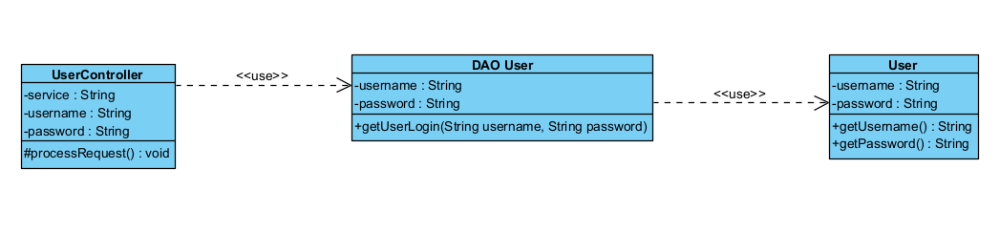

### b. Class Specifications

#### UserController Class

|  |  |  |
| --- | --- | --- |
| **No** | **Method** | **Description** |
| *01* | *process Request* | *Take username and password that user enter and pass to DAO User. Redirect to Homepage if DAO User return a user else redirect to Login page if DAO User return null* |

#### DAOUser Class

|  |  |  |
| --- | --- | --- |
| **No** | **Method** | **Description** |
| *01* | *getUserLogin(String username,String password)* | *Input : username and password from UserController*  *Ouput: return user* |

#### User Class

|  |  |  |
| --- | --- | --- |
| **No** | **Method** | **Description** |
| *01* | *getUsername()* | *Return the username of the user* |
| *02* | *getPassword()* | *Return the password of the user* |

### 

### c. Sequence Diagram

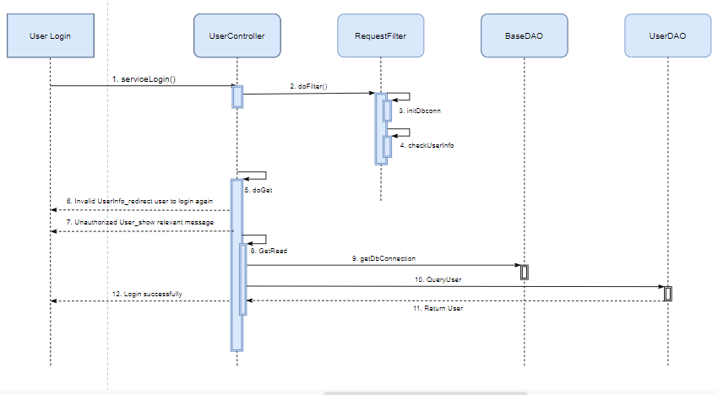

### d. Database queries

*SELECT * FROM [User] WHERE username = ? and password = ? and status = 1*

## 

## 2. <Sign up>

### a. Class Diagram

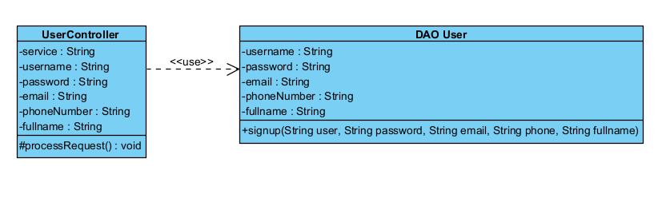

### b. Class Specifications

#### UserConttoller Class

|  |  |  |
| --- | --- | --- |
| **No** | **Method** | **Description** |
| *01* | *processRequest* | *Pass information to DAO User.* |

#### DAO UserClass

|  |  |  |
| --- | --- | --- |
| **No** | **Method** | **Description** |
| *01* | *Signup(String username,String password,String email,String phone,String fullname)* | *Take information and check condition of username, mail and phoneNumber (Username, mail and phone must be distinct). If the conditon is sastified, create a new user.* |

### c. Sequence Diagram

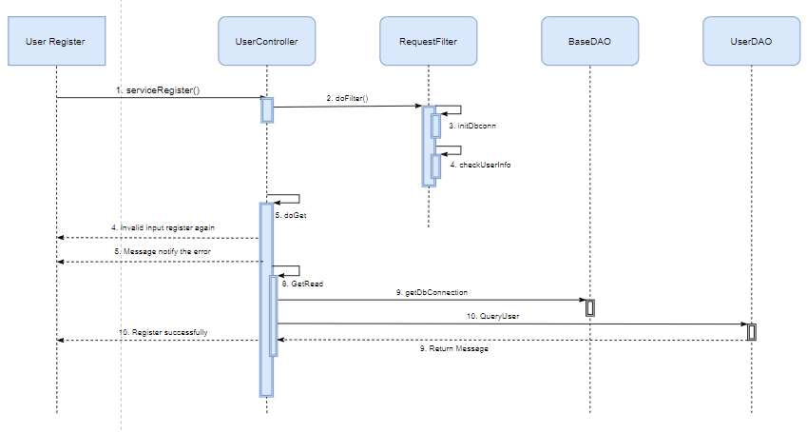

### d. Database queries

# *INSERT INTO [User]([username],[password],[email],[phoneNumber],[fullname],[systemRole],[status]) VALUES (?,?,?,?,?,0,1)*

## 3. <Forgot password >

**a. Class Diagram**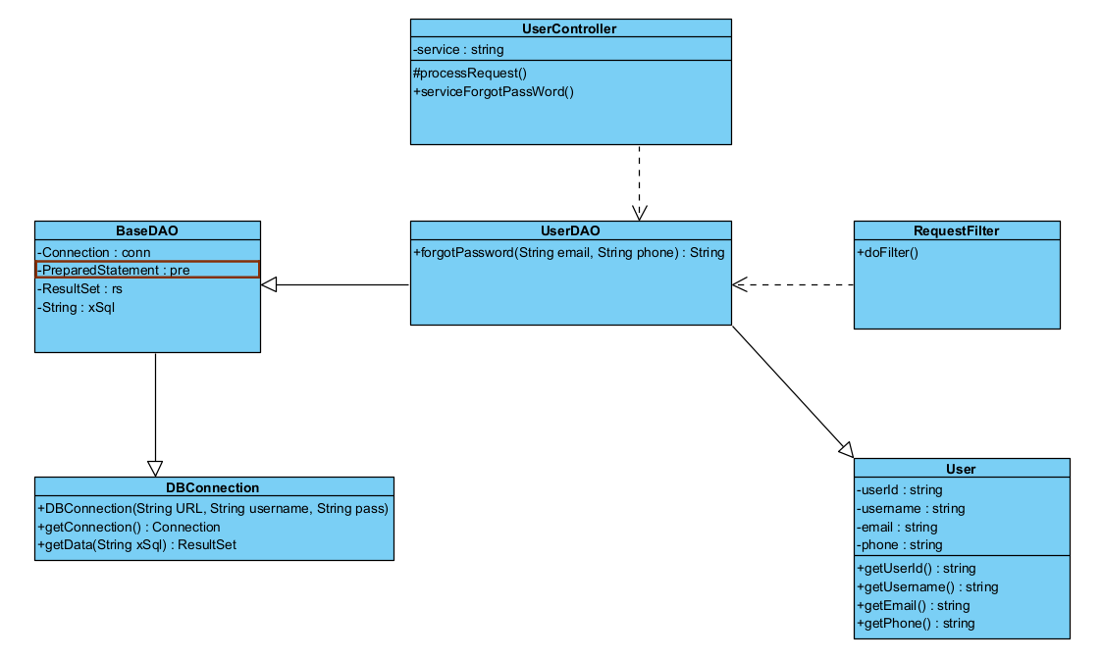

### b. Class Specifications

### c. Sequence Diagram

### https://lh3.googleusercontent.com/N_9miigAKQrI9xx2A3PGeLHhXdEDUrJw3QrgdXbkwC9-dcgtbl2vwzgmOcnlDEhgmwKUuccsDKLib1WS71Pb_FJtjtOL0suSAuvlBCgrkfIhTSN9mePL2yotaewVPwRi23ohWOJv=s0

### d. Database queries

# *SELECT * FROM [User] WHERE username = '" + username + "' and status=1*

# *Update [User] set password = ? where username = ?*

## 4. <Change password>

**a. Class Diagram**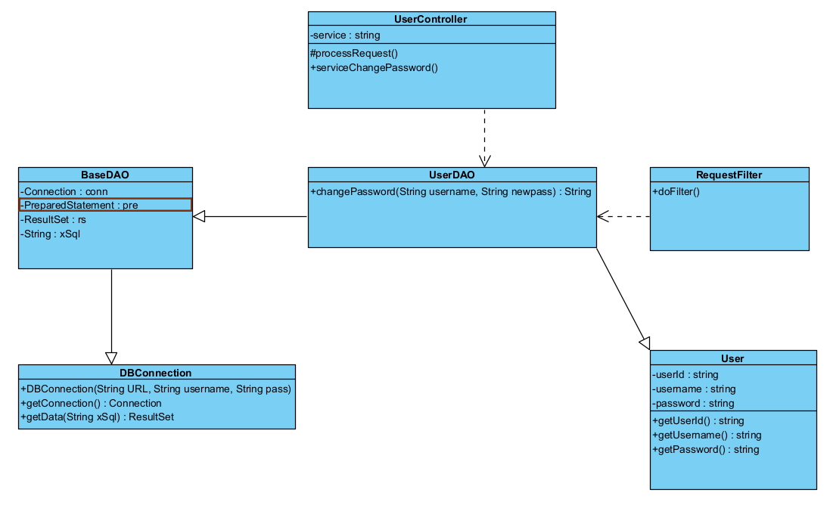b. **b.Class Specifications**

### c. Sequence Diagram

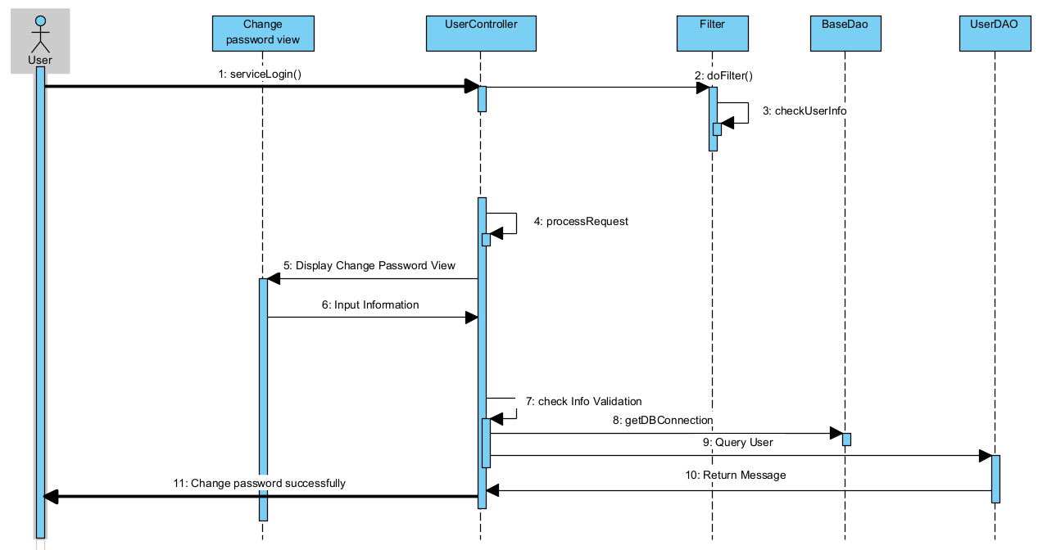

### d. Database queries

# *update [User] set password = ? where username = ?*

## 5. <Home Page>

**a. Class Diagram**

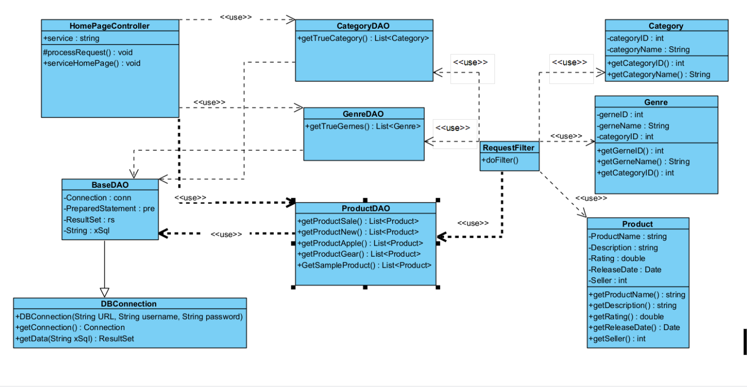

### b. Class Specifications

### c. Sequence Diagram

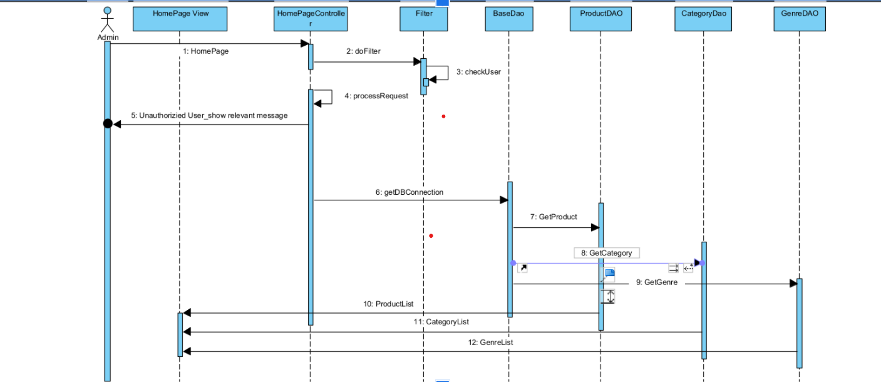

### d. Database queries

# *SELECT TOP 8 * FROM Product order by releaseDate*

# *SELECT TOP 8 * FROM Product order by sale*

# *SELECT TOP 8 * FROM Product where description like '%apple%'*

## 6. <Product List>

**a. Class Diagram**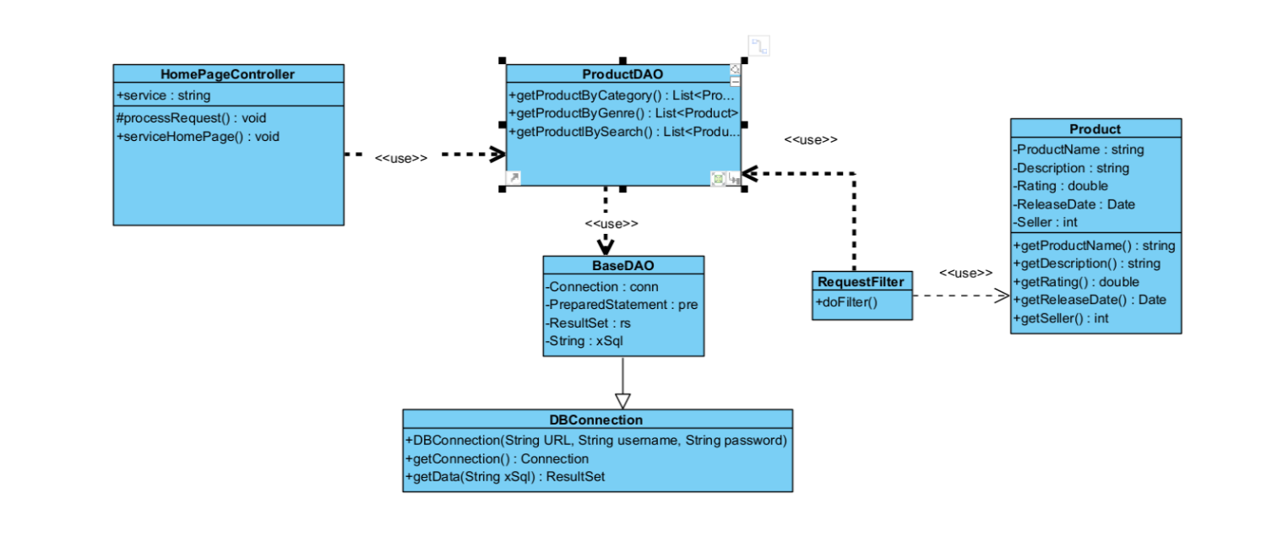

### b. Class Specifications

### c. Sequence Diagramhttps://cdn.discordapp.com/attachments/884655310638284882/891696066636939324/unknown.png

### d. Database queries

# *SELECT * FROM Product order by releaseDate*

## 7. <Profile Page>

**a. Class Diagram**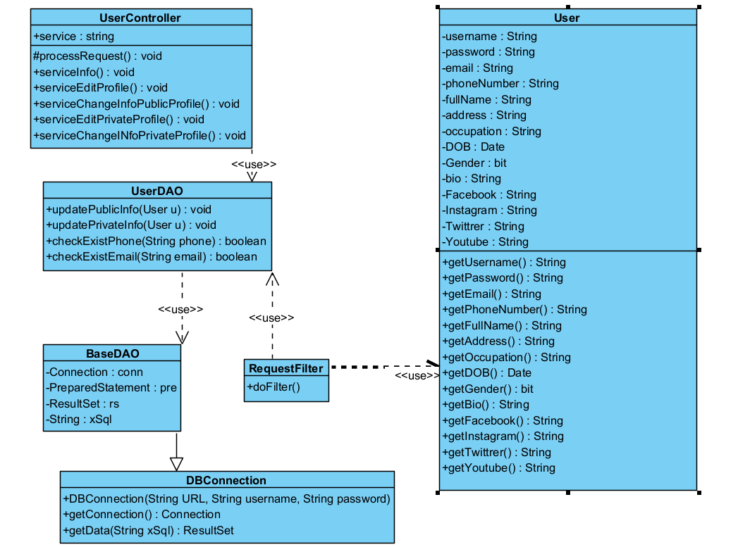

### b. Class Specifications

### c. Sequence Diagramhttps://lh4.googleusercontent.com/OQObek0Vzu-KAXJShwxkPJhLfdEZJBaoj93nOEwYbAQh0HB_rfdsibZ4ahUzcHIe_QRCIyquf0Tpwvz5fd-abxGv9qPx7FU3TKpKlJHwV1NQldFr_pzpzPJm41AA0Y55BDniiBf9=s0

### d. Database queries

# *SELECT * FROM User WHERE UserID = ?*

## 8. <Edit profile>

**a. Class Diagram**

### b. Class Specifications

### c. Sequence Diagram

### - Public:

### https://lh5.googleusercontent.com/W1F-7fTLKYpr0Es3htDPyzyONXw2F-j138vlYk4PUeJVsj1HwF_cesIbqYWGBmCAHRpkQgSJXNUENnEeoak5sq9jBmLS3LX5s6hEEpdZByifGgazl9A-51N_-iW1O1Ndol6aqeN_=s0

### - Private: https://lh5.googleusercontent.com/wU59lBmtUQklc6CEje0UcNemyEtD_saFPpTAIJl62iIEsxgLJQBBIayMNGuZx0BHlwC3vhXcC1uqOtkmvQS7KQzZoyKrAyZkWY2OgWvBlqmcex_mY11rCMzEKtWhXnTNM-_oD6xB=s0

### d. Database queries

- Pulblic profile:

# *UPDATE [User] SET  username=?, [address]=?, bio=?, Facebook=?, Instagram=?, Twitter=?, Youtube=? , [password]=? where userID=?*

- Private profile:

# *UPDATE [User] SET  fullname=?, email=?, phoneNumber=?, [password]=?  where userID=?*

## 9. <User Management>

**a. Class Diagram**

### b. Class Specifications

### c. Sequence Diagramhttps://lh3.googleusercontent.com/6YByIFqeb6mQyMoQAvC1fr0-TdghDjE4cbj6HENnQjMOrL0hA5UUauQi77hMa6v3UaY8vghLj3iVBLryxpZipUyXPoKVpXHu262t6zpaAIZ9TNYQgVL64CDROCj1io80VjuouMAl=s0https://lh4.googleusercontent.com/M-yGYhBbMLx1VmjbYfZfk18vop4dahwdNSqHls-Di9qgAN0SiU-gVkw4gDcAMCvl6NcloHfMyQYzY8mKTVRKE3yno5eO1wmYdNOgaz8GbNirjuFbsOpNESQNL4dv31fRN7-P-iiW=s0

### d. Database queries

## 10. <Product Management>

**a. Class Diagram**

### b. Class Specifications

### c. Sequence Diagramhttps://lh4.googleusercontent.com/goBDk4v8k2zTUxtgCmTu1WC3vcKEZiG38IUx0jbNhZs1gXbsS97IyGc9lrhf-wDMppv8FfmL0E2mnriKsy5jjdj4GjvaXo8tbadFT7xRmqbkS2XduBqUuaD1V75S0oEvSSVXLYhY=s0https://lh3.googleusercontent.com/md0JuumU8t6awRW5t8WWOLuU5f3LdgISVqO7lGVC0exNOGY41zK6lf3CMG0QbzB58aZ8PIWljRwqax_kVJr02i2x9z30CcZJYXZltmkFC1gGykT7qLXqH8XPzdigR57JVIEnKHu4=s0

### d. Database queries

# III. Database Design

## 1. Database Schema

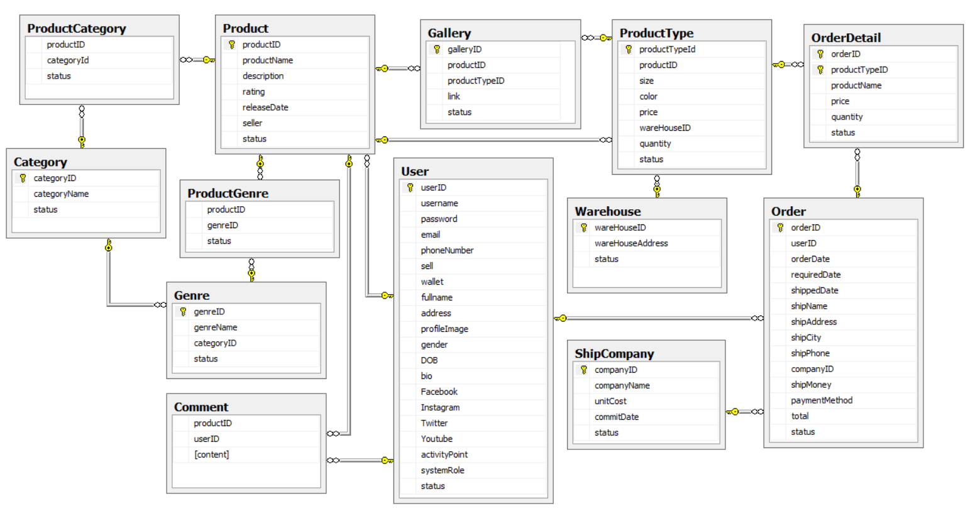

## 2. Table Description

**Table User**

|  |  |  |  |
| --- | --- | --- | --- |
| **Field Name** | **Data Type** | **Constraint** | **Description** |
| **userID** | **int** | Primary Key | ID of user. |
| **username** | **nvarchar(255)** |  |  |
| **password** | **nvarchar(255)** |  |  |
| **email** | **nvarchar(255)** |  |  |
| **phoneNumber** | **nvarchar(255)** |  |  |
| **sell** | **bit** |  | User is a seller or not. |
| **wallet** | **money** |  | User’s wallet. |
| **fullname** | **nvarchar(255)** |  |  |
| **address** | **nvarchar(255)** |  |  |
| **profileImage** | **nvarchar(255)** |  |  |
| **gender** | **bit** |  |  |
| **DOB** | **date** |  | Date of birth. |
| **bio** | **nvarchar(255)** |  | General information. |
| **Facebook** | **nvarchar(255)** |  |  |
| **Instagram** | **nvarchar(255)** |  |  |
| **Twitter** | **nvarchar(255)** |  |  |
| **Youtube** | **nvarchar(255)** |  |  |
| **activityPoint** | **int** |  |  |
| **systemRole** | **nvarchar(255)** |  |  |
| **status** | **bit** |  |  |

**Table Category**

|  |  |  |  |
| --- | --- | --- | --- |
| **Field Name** | **Data Type** | **Constraint** | **Description** |
| **categoryID** | **int** | Primary Key | ID of category of product. |
| **categoryName** | **nvarchar(255)** |  | Name of category |
| **status** | **bit** |  |  |

**Table Genre**

|  |  |  |  |
| --- | --- | --- | --- |
| **Field Name** | **Data Type** | **Constraint** | **Description** |
| **genreID** | **int** | Primary Key | ID of genre of product. |
| **genreName** | **nvarchar(255)** |  | Name of genre. |
| **categoryID** | **int** | Foreign Key | ID of category of product. |
| **status** | **bit** |  |  |

**Table WareHouse**

|  |  |  |  |
| --- | --- | --- | --- |
| **Field Name** | **Data Type** | **Constraint** | **Description** |
| **wareHouseID** | **int** | Primary Key | ID of warehouse. |
| **wareHouseAddress** | **nvarchar(255)** |  |  |
| **status** | **bit** |  |  |

**Table Product**

|  |  |  |  |
| --- | --- | --- | --- |
| **Field Name** | **Data Type** | **Constraint** | **Description** |
| **productID** | int | Primary Key | ID of product. |
| **productName** | **nvarchar(255)** |  | Name of product. |
| **description** | **nvarchar(max)** |  | General information. |
| **rating** | int |  | Rating point of product. |
| **releaseDate** | date |  |  |
| **seller** | int | Foreign Key |  |
| **status** | bit |  |  |

**Table Comment**

|  |  |  |  |
| --- | --- | --- | --- |
| **Field Name** | **Data Type** | **Constraint** | **Description** |
| **productID** | int | Foreign Key |  |
| **userID** | int | Foreign Key |  |
| **content** | **nvarchar(255)** |  |  |

**Table ProductGenre**

|  |  |  |  |
| --- | --- | --- | --- |
| **Field Name** | **Data Type** | **Constraint** | **Description** |
| **productID** | int | Foreign Key |  |
| **genreID** | int | Foreign Key |  |
| **status** | bit |  |  |

**Table ProductCategory**

|  |  |  |  |
| --- | --- | --- | --- |
| **Field Name** | **Data Type** | **Constraint** | **Description** |
| **productID** | int | Foreign Key |  |
| **categoryId** | int | Foreign Key |  |
| **status** | bit |  |  |

**Table ProductType**

|  |  |  |  |
| --- | --- | --- | --- |
| **Field Name** | **Data Type** | **Constraint** | **Description** |
| **productTypeId** | int | Primary Key | ID of type of product. |
| **productID** | int | Foreign Key |  |
| **size** | **nvarchar(255)** |  |  |
| **color** | **nvarchar(255)** |  |  |
| **price** | money |  |  |
| **wareHouseID** | int | Foreign Key |  |
| **quantity** | int |  |  |
| **status** | bit |  |  |

**Table ShipCompany**

|  |  |  |  |
| --- | --- | --- | --- |
| **Field Name** | **Data Type** | **Constraint** | **Description** |
| **companyID** | int | Primary Key |  |
| **companyName** | **nvarchar(255)** |  |  |
| **unitCost** | **money** |  |  |
| **commitDate** | int |  |  |
| **status** | bit |  |  |

**Table Gallery**

|  |  |  |  |
| --- | --- | --- | --- |
| **Field Name** | **Data Type** | **Constraint** | **Description** |
| **galleryID** | int | Primary Key |  |
| **productID** | int | Foreign Key |  |
| **productTypeID** | **nvarchar(255)** | Foreign Key |  |
| **link** | **nvarchar(255)** |  |  |
| **status** | bit |  |  |

**Table Order**

|  |  |  |  |
| --- | --- | --- | --- |
| **Field Name** | **Data Type** | **Constraint** | **Description** |
| **orderID** | int | Primary Key |  |
| **userID** | int | Foreign Key |  |
| **orderDate** | datetime |  |  |
| **requiredDate** | datetime |  |  |
| **shippedDate** | datetime |  |  |
| **shipName** | **nvarchar(255)** |  |  |
| **shipAddress** | **nvarchar(255)** |  |  |
| **shipCity** | **nvarchar(255)** |  |  |
| **shipPhone** | **nvarchar(255)** |  |  |
| **companyID** | int | Foreign Key |  |
| **shipMoney** | money |  |  |
| **paymentMethod** | **nvarchar(50)** |  |  |
| **total** | money |  |  |
| **status** | bit |  |  |

**Table OrderDetail**

|  |  |  |  |
| --- | --- | --- | --- |
| **Field Name** | **Data Type** | **Constraint** | **Description** |
| **orderID** | Int | Foreign Key |  |
| **productTypeID** | **nvarchar(255)** | Foreign Key |  |
| **productName** | **nvarchar(255)** |  |  |
| **price** | money |  |  |
| **quantity** | int |  |  |
| **status** | bit |  |  |